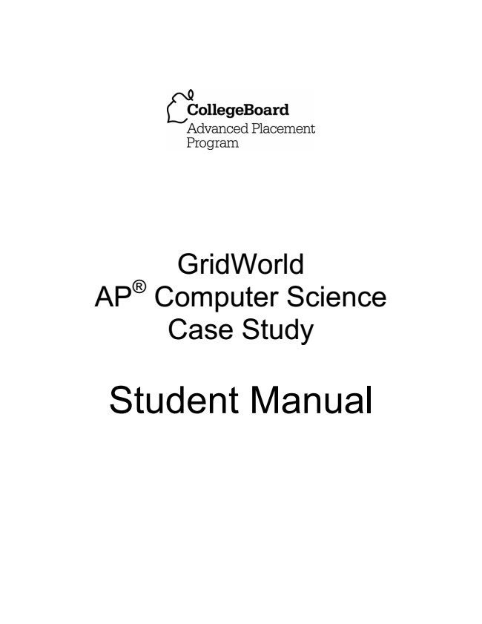

GridWorld AP® Computer Science Case Study

Student Manual

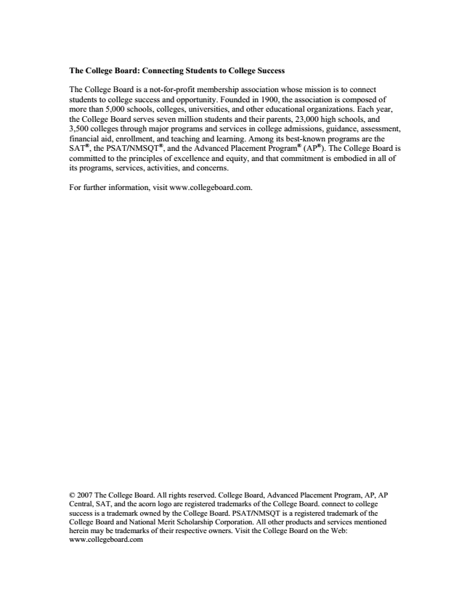

**The College Board: Connecting Students to College Success**

The College Board is a not-for-profit membership association whose mission is to connect students to college success and opportunity. Founded in 1900, the association is composed of more than 5,000 schools, colleges, universities, and other educational organizations. Each year, the College Board serves seven million students and their parents, 23,000 high schools, and 3,500 colleges through major programs and services in college admissions, guidance, assessment, financial aid, enrollment, and teaching and learning. Among its best-known programs are the SAT®, the PSAT/NMSQT®, and the Advanced Placement Program® (AP®). The College Board is committed to the principles of excellence and equity, and that commitment is embodied in all of its programs, services, activities, and concerns.

For further information, visit www.collegeboard.com.

© 2007 The College Board. All rights reserved. College Board, Advanced Placement Program, AP, AP Central, SAT, and the acorn logo are registered trademarks of the College Board. connect to college success is a trademark owned by the College Board. PSAT/NMSQT is a registered trademark of the College Board and National Merit Scholarship Corporation. All other products and services mentioned herein may be trademarks of their respective owners. Visit the College Board on the Web: www.collegeboard.com

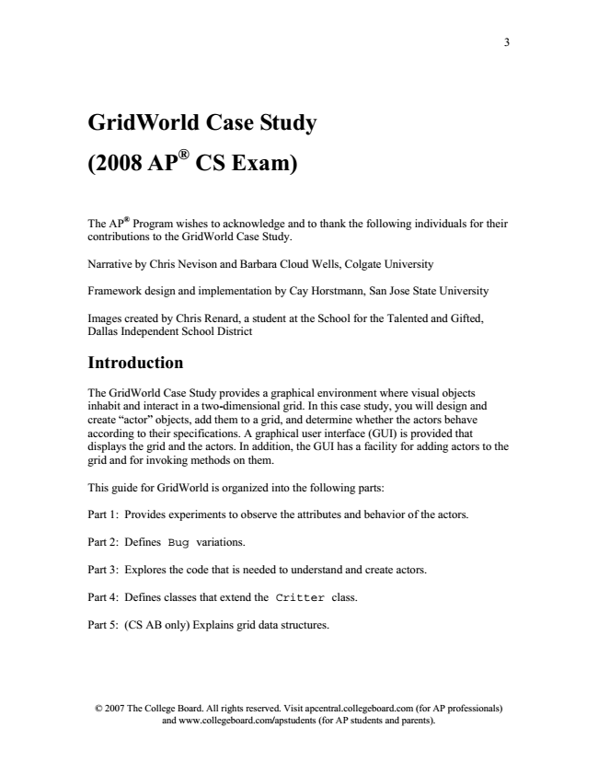

3

**GridWorld Case Study (2008 AP® CS Exam)**

The AP

®

Program wishes to acknowledge and to thank the following individuals for their contributions to the GridWorld Case Study.

Narrative by Chris Nevison and Barbara Cloud Wells, Colgate University

Framework design and implementation by Cay Horstmann, San Jose State University

Images created by Chris Renard, a student at the School for the Talented and Gifted, Dallas Independent School District

**Introduction**

The GridWorld Case Study provides a graphical environment where visual objects inhabit and interact in a two-dimensional grid. In this case study, you will design and create “actor” objects, add them to a grid, and determine whether the actors behave according to their specifications. A graphical user interface (GUI) is provided that displays the grid and the actors. In addition, the GUI has a facility for adding actors to the grid and for invoking methods on them.

This guide for GridWorld is organized into the following parts:

Part 1: Provides experiments to observe the attributes and behavior of the actors.

Part 2: Defines Bug variations.

Part 3: Explores the code that is needed to understand and create actors.

Part 4: Defines classes that extend the Critter class.

Part 5: (CS AB only) Explains grid data structures.

© 2007 The College Board. All rights reserved. Visit apcentral.collegeboard.com (for AP professionals) and www.collegeboard.com/apstudents (for AP students and parents).

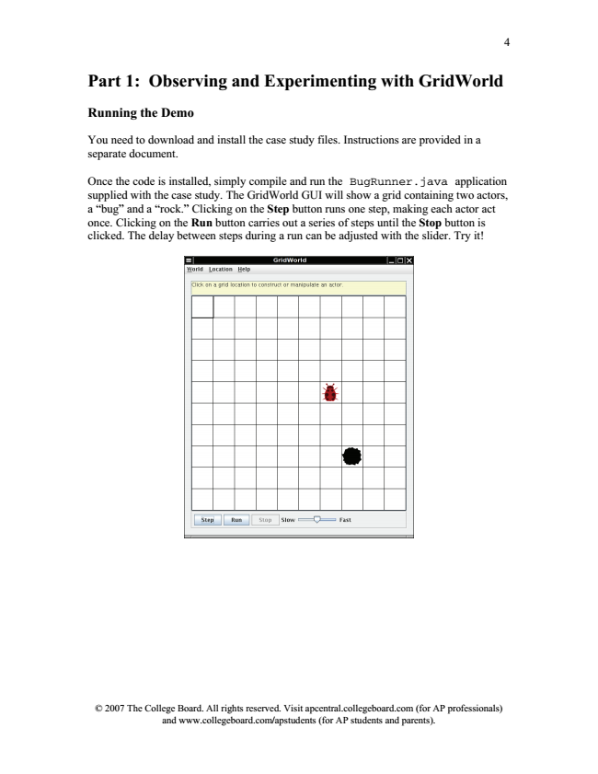

4

**Part 1: Observing and Experimenting with GridWorld**

**Running the Demo**

You need to download and install the case study files. Instructions are provided in a separate document.

Once the code is installed, simply compile and run the BugRunner.java application supplied with the case study. The GridWorld GUI will show a grid containing two actors, a “bug” and a “rock.” Clicking on the Step button runs one step, making each actor act once. Clicking on the Run button carries out a series of steps until the Stop button is clicked. The delay between steps during a run can be adjusted with the slider. Try it!

© 2007 The College Board. All rights reserved. Visit apcentral.collegeboard.com (for AP professionals) and www.collegeboard.com/apstudents (for AP students and parents).

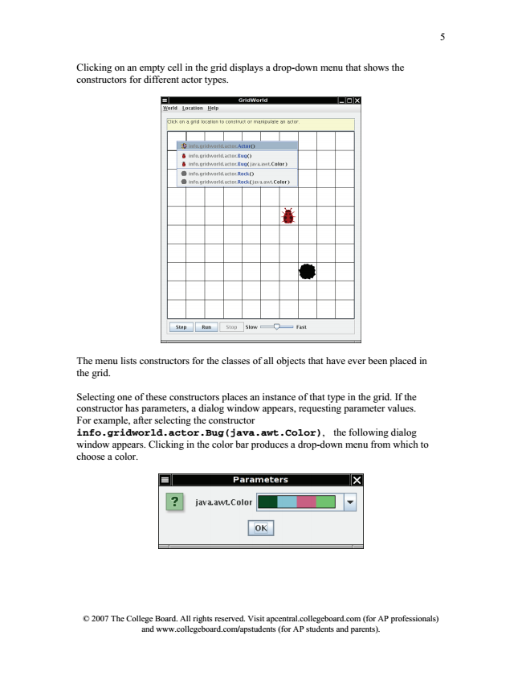

5

Clicking on an empty cell in the grid displays a drop-down menu that shows the constructors for different actor types.

The menu lists constructors for the classes of all objects that have ever been placed in the grid.

Selecting one of these constructors places an instance of that type in the grid. If the constructor has parameters, a dialog window appears, requesting parameter values. For example, after selecting the constructor info.gridworld.actor.Bug(java.awt.Color), the following dialog window appears. Clicking in the color bar produces a drop-down menu from which to choose a color.

© 2007 The College Board. All rights reserved. Visit apcentral.collegeboard.com (for AP professionals) and www.collegeboard.com/apstudents (for AP students and parents).

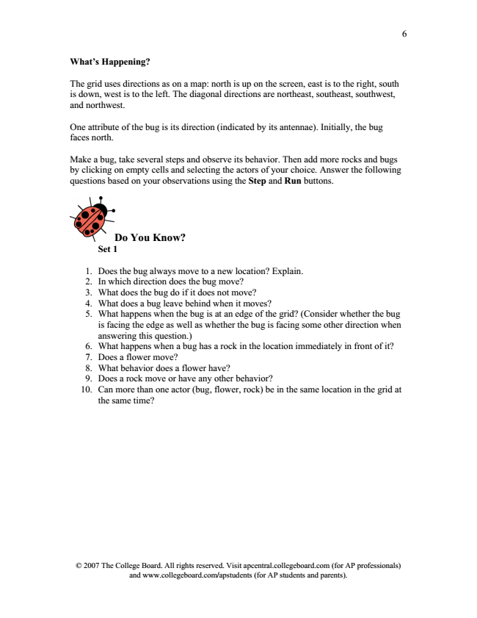

6

**What’s Happening?**

The grid uses directions as on a map: north is up on the screen, east is to the right, south is down, west is to the left. The diagonal directions are northeast, southeast, southwest, and northwest.

One attribute of the bug is its direction (indicated by its antennae). Initially, the bug faces north.

Make a bug, take several steps and observe its behavior. Then add more rocks and bugs by clicking on empty cells and selecting the actors of your choice. Answer the following questions based on your observations using the Step and Run buttons.

© 2007 The College Board. All rights reserved. Visit apcentral.collegeboard.com (for AP professionals) and www.collegeboard.com/apstudents (for AP students and parents).

**Do You Know? Set 1**

1. Does the bug always move to a new location? Explain. 2. In which direction does the bug move? 3. What does the bug do if it does not move? 4. What does a bug leave behind when it moves? 5. What happens when the bug is at an edge of the grid? (Consider whether the bug is facing the edge as well as whether the bug is facing some other direction when answering this question.) 6. What happens when a bug has a rock in the location immediately in front of it? 7. Does a flower move? 8. What behavior does a flower have? 9. Does a rock move or have any other behavior? 10. Can more than one actor (bug, flower, rock) be in the same location in the grid at

the same time?

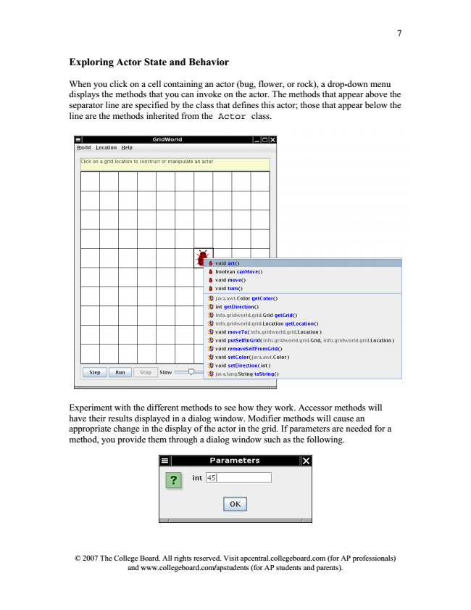

7

**Exploring Actor State and Behavior**

When you click on a cell containing an actor (bug, flower, or rock), a drop-down menu displays the methods that you can invoke on the actor. The methods that appear above the separator line are specified by the class that defines this actor; those that appear below the line are the methods inherited from the Actor class.

Experiment with the different methods to see how they work. Accessor methods will have their results displayed in a dialog window. Modifier methods will cause an appropriate change in the display of the actor in the grid. If parameters are needed for a method, you provide them through a dialog window such as the following.

© 2007 The College Board. All rights reserved. Visit apcentral.collegeboard.com (for AP professionals) and www.collegeboard.com/apstudents (for AP students and parents).

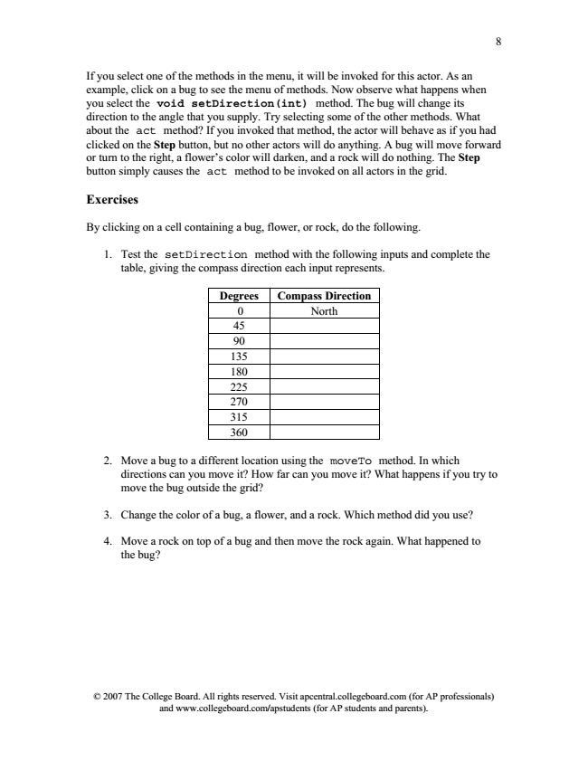

8

If you select one of the methods in the menu, it will be invoked for this actor. As an example, click on a bug to see the menu of methods. Now observe what happens when you select the void setDirection(int) method. The bug will change its direction to the angle that you supply. Try selecting some of the other methods. What about the act method? If you invoked that method, the actor will behave as if you had clicked on the Step button, but no other actors will do anything. A bug will move forward or turn to the right, a flower’s color will darken, and a rock will do nothing. The Step button simply causes the act method to be invoked on all actors in the grid.

**Exercises**

By clicking on a cell containing a bug, flower, or rock, do the following.

1. Test the setDirection method with the following inputs and complete the

table, giving the compass direction each input represents.

**Degrees Compass Direction**

0 North 45 90 135 180 225 270 315 360

2. Move a bug to a different location using the moveTo method. In which

directions can you move it? How far can you move it? What happens if you try to move the bug outside the grid?

3. Change the color of a bug, a flower, and a rock. Which method did you use?

4. Move a rock on top of a bug and then move the rock again. What happened to

the bug?

© 2007 The College Board. All rights reserved. Visit apcentral.collegeboard.com (for AP professionals) and www.collegeboard.com/apstudents (for AP students and parents).

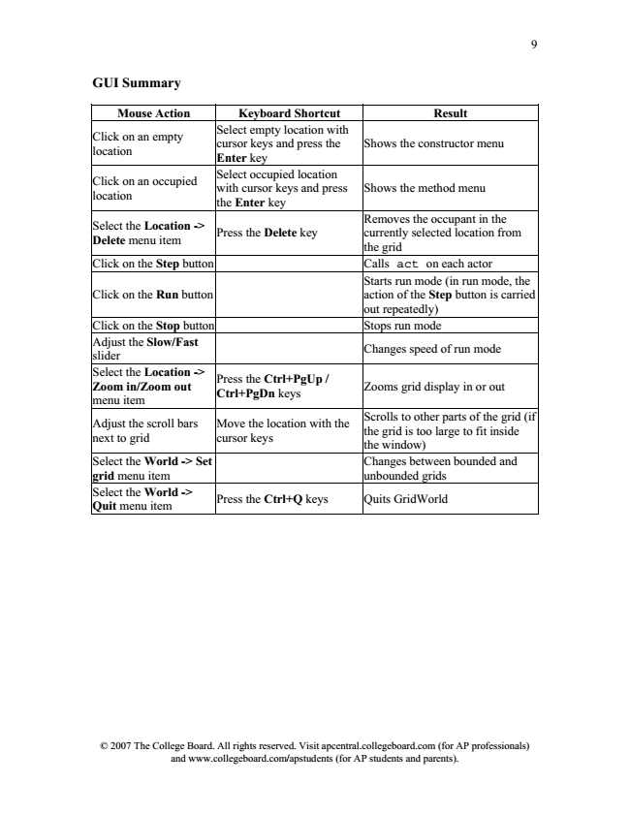

9

**GUI Summary**

**Mouse Action Keyboard Shortcut Result**

Click on an empty location

Select empty location with cursor keys and press the Enter key

Shows the constructor menu

Click on an occupied location

Select occupied location with cursor keys and press the Enter key

Shows the method menu

Select the Location -> Delete menu item

Removes the occupant in the currently selected location from the grid Click on the Step button Calls act on each actor

Click on the Run button

Press the Delete key

Starts run mode (in run mode, the action of the Step button is carried out repeatedly) Click on the Stop button Stops run mode Adjust the Slow/Fast slider

Changes speed of run mode

**Select the Location -> Zoom in/Zoom out menu item**

**Press the Ctrl+PgUp / Ctrl+PgDn keys**

Zooms grid display in or out

Adjust the scroll bars next to grid

Scrolls to other parts of the grid (if the grid is too large to fit inside the window) Select the World -> Set grid menu item

Move the location with the cursor keys

Changes between bounded and unbounded grids Select the World -> Quit menu item

Press the Ctrl+Q keys Quits GridWorld

© 2007 The College Board. All rights reserved. Visit apcentral.collegeboard.com (for AP professionals) and www.collegeboard.com/apstudents (for AP students and parents).

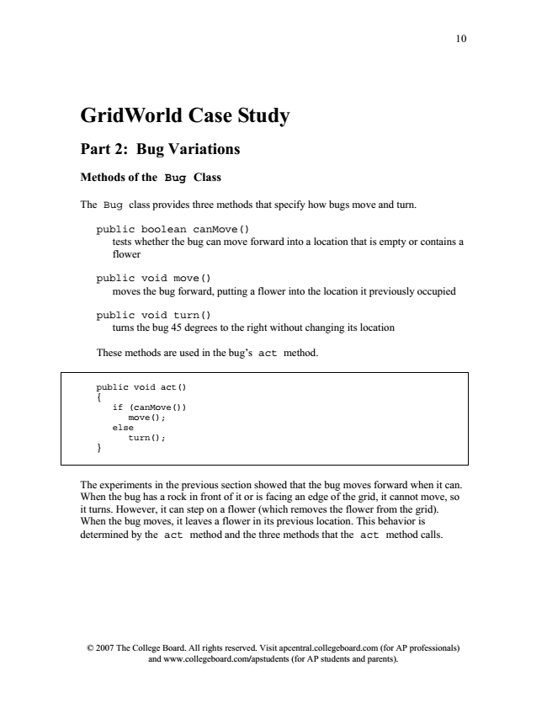

10

**GridWorld Case Study**

**Part 2: Bug Variations**

**Methods of the Bug Class**

The Bug class provides three methods that specify how bugs move and turn.

public boolean canMove()

tests whether the bug can move forward into a location that is empty or contains a flower

public void move()

moves the bug forward, putting a flower into the location it previously occupied

public void turn()

turns the bug 45 degrees to the right without changing its location

These methods are used in the bug’s act method.

public void act() {

if (canMove())

move(); else

turn(); }

The experiments in the previous section showed that the bug moves forward when it can. When the bug has a rock in front of it or is facing an edge of the grid, it cannot move, so it turns. However, it can step on a flower (which removes the flower from the grid). When the bug moves, it leaves a flower in its previous location. This behavior is determined by the act method and the three methods that the act method calls.

© 2007 The College Board. All rights reserved. Visit apcentral.collegeboard.com (for AP professionals) and www.collegeboard.com/apstudents (for AP students and parents).